SUBJECT LINE: Cash balance – A rapidly growing, differentiated retirement plan benefit


In my previous email, I explained how cash balance plans can help advisors drive asset growth in partnership with business owners—while helping these clients accelerate their retirement savings and reduce their taxes.

Cash balance plans have seen rapid growth in adoption among businesses because they offer significantly higher contribution limits than 401(k) plans and potentially large tax deductions, as shown in this infographic:

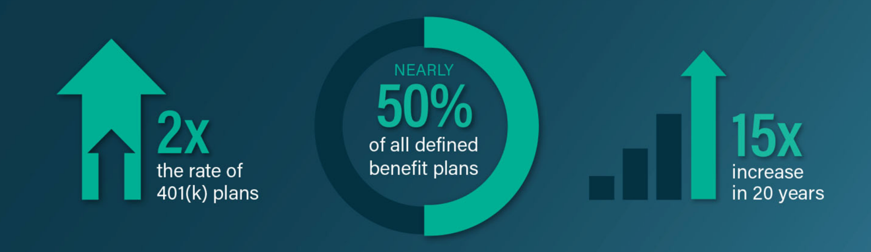

To illustrate how advisors are using cash balance plans to transform their practices, this case study shows how one Merrill advisor used cash balance plans to generate more than $1 million in annual asset inflows plus $5 million in private wealth assets from just five business owners.

You can find additional cash balance details on Merrill’s RCMA Investment Only Resource Central advisor site, including the Advisor Playbook, a guide for selling and implementing cash balance plans.

Please let me know when you have 30 minutes to discuss how I can support you and help the advisors you serve.

Thanks,
John Doe
JohnDoe@futureplan.com
718-111-1111

www.futureplan.com

FuturePlan by Ascensus provides plan design, administration, and compliance services. It is not a broker-dealer or an investment advisor and does not provide tax, legal, or accounting services.
Copyright ©2025, Ascensus LLC. All rights reserved.

